Warning – Remote Start – CGEA1.3

Functional Description

The purpose of the Remote Start Warning feature is to inform the driver that the vehicle is in the remote start active state and how to change the state to a drivable (motive) state. This STSS handles PEPS, non-PEPS, and shift by wire vehicles. Thus, this STSS is used for both keyed vehicles and keyless vehicles.

This display is active as soon as the vehicle is remote started (i.e., the engine is running, but the ignition status is off). The display follows a CAN signal, which will cause the display to be removed when remote start is exited for any reason (whether faulted or transitioned to ignition RUN – i.e., now in drivable state). The Remote Start Warning feature correlates the Remote_Start_Status Signal, configuration information, and the operational mode to display the appropriate warning display in the message center.

This STSS revision updates to a new strategy for Shift By Wire vehicles. Applications engineers should verify with powertrain engineers to ensure that the new strategy can be adopted for his or her particular program. The strategy in Warning – Remote Start_v1.0 may be used if powertrain cannot support the new warning text (e.g., To Drive: Push Brake and Gear Select). The first application of this STSS will be the C489 program.

Interfaces

Interface Context Diagram (I/O Block Diagram)
Figure 1 Warning – Remote Start Context Diagram
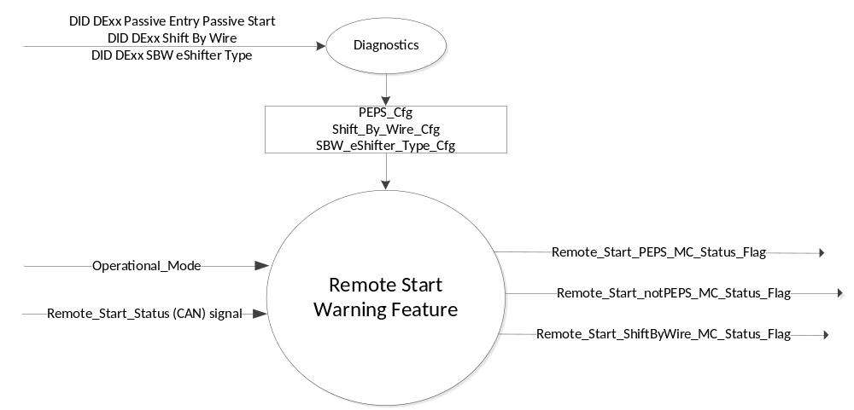

Inputs
      - INTERNAL:
            - Operational_Mode
            - PEPS_Cfg
            - Shift_By_Wire_Cfg
            - SBW_eShifter_Type_Cfg

- MUX message from the CAN bus

- Remote_Start_Status Signal
Signal Name | Size (bits) | Detail | Units | Res. | Offset | State Encoded | Min | Max
Remote_Start_Status | 2 |  | SED | 1 | 0 |  | 0 (0x0) | 3 (0x3)
 |  | Null |  |  |  | 0x0
 |  | Remote |  |  |  | 0x1
 |  | Unknown |  |  |  | 0x2
 |  | Invalid |  |  |  | 0x3

Outputs
- Remote_Start_PEPS_MC_Status_Flag that is used to control the Warning displayed in the message center.
- Remote_Start_notPEPS_MC_Status_Flag that is used to control the Warning displayed in the message center.
- Remote_Start_ShiftByWire_MC_Status_Flag that is used to control the Warning displayed in the message center.

Function/Performance

Operational Modes

Mode | Differentiating Vehicle Conditions
Sleep Mode | OFF
Limited Mode | Remote Start Control Function Text Messages OFF/ON
Normal Mode | OFF
Crank Mode | OFF

Voltage Levels

Refer to the Cluster Features Table located in the Operational Modes and Voltage Range Strategies Section of this SPSS.

Human-Machine Interface

Visual

Indicator Graphics / Display Format
Refer to the appropriate Message Center Text Message List file for Message ID W603, W613, and W2100.

1.3.3.1.2 Indicator Color Coordinates

Reference section COLOR & ILLUMINATION REQUIREMENTS (GRAPHICS)

1.3.3.1.3 Indicator Characteristics

Refer to appropriate Message Center Display and Button Interface file.

Audio

All warnings in this STSS do not have an associated Message Center chime.

Switch Control Logic

Consumer access to Message Center Warnings shall be as specified in the message center basic functionality display as specified in the appropriate Message Center Display and Button Interface file.

System Accuracy

- The state of the message center flags shall change within 100 msec of a state change as indicated in the state matrix found in Section 1.3.5.1 of this document

Operation: Performance and Functional

Subsystem Algorithm Flowchart / State Diagram

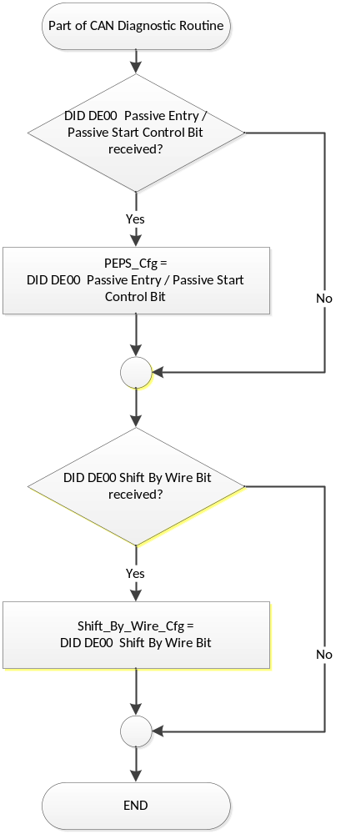

- State Matrix for Remote Start Warning MC Status Flags
Operational_ Mode | Remote_Start_Status Signal | Shift_By_  Wire_Cfg | PEPS_Cfg | SBW_eShifter_  Type_Cfg | Remote_Start_  notPEPS_  MC_Status_  Flag | Remote_Start_  PEPS_  MC_Status_  Flag | Remote_Start_  ShiftByWire_  MC_Status_  Flag
Limited | Remote (0x1) | Disabled | Disabled | X | Active | Inactive | Inactive
Limited | Remote (0x1) | Disabled | Enabled | X | Inactive | Active | Inactive
Limited | Remote (0x1) | Enabled | Disabled | X | Active | Inactive | Inactive
Limited | Remote (0x1) | Enabled | Enabled | Push Button | Inactive | Inactive | Active
 |  |  |  | Rotary Dial | Inactive | Active | Inactive
All Other Cases |  |  |  |  | Inactive | Inactive | Inactive

- Remote_Start Warning MC Status Flags to MC Warning Message ID and MC Warning Chime
Description of Warning | MC_Status_Flag | MC WARNING TYPE | Mc Warning Message ID | CHIME
This message is displayed if a PEPS vehicle is currently in the Remote Start state. It helps the operator understand that they need to depress the brake and the START Button to be able go from Remote Start state to the Run state and thus be able to drive the vehicle. | Remote_Start_PEPS_MC_Status_Flag | NR | W613 | None
This message is displayed if a keyed vehicle is currently in the Remote Start state. It helps the operator understand that they need to turn the ignition key to START to be able go from Remote Start state to the Run state and thus be able to drive the vehicle. | Remote_Start_notPEPS_MC_Status_Flag | NR | W603 | None
This message is displayed if a Shift by Wire vehicle is currently in the Remote Start state. It helps the operator understand that they need to depress the brake and press the gear shift button to be able to go from Remote Start state to the Run state and thus be able to drive the vehicle. | Remote_Start_ShiftByWire_MC_Status_Flag | NR | W2100 | None

Operation Description (supports algorithm flowchart /state diagram)

- For definition of how the Message Center arbitrates and displays Active warnings, see the Warning / Alert Display Logic Diagram, located in the appropriate Message Center Display and Button Interface STSS.

- Active displays of W603, W613, or W2100 are a local sleep inhibitor.

- Since these are limited mode warnings, there is no “missing message” case. Note that if a CAN network failure would happen to occur while the warning was active, then the cluster would continue to display the warning until Low Voltage Shutdown occurred. Also note that during remote start, the SPDJB asserts the RUN/START ignition circuit (although Ignition_Status CAN signal is OFF), and does not allow the CAN networks to sleep.

Function Safety Classification (EMC)

Class B

Memory Storage

Parameter Name | Description | Value at  Battery Connect | Value at  Module  Wake-up
Remote_Start_PEPS_MC_Status_Flag | Used to control the state of the warning to the Message Center arbitrator. | INACTIVE (0x0) | INACTIVE (0x0)
Remote_Start_notPEPS_MC_Status_Flag | Used to control the state of the warning to the Message Center arbitrator. | INACTIVE (0x0) | INACTIVE (0x0)
Remote_Start_ShiftByWire_MC_Status_Flag | Used to control the state of the warning to the Message Center arbitrator. | INACTIVE (0x0) | INACTIVE (0x0)
PEPS_Cfg | State Indicator for feature presence controlled via CAN at EOL at VO plant. Defaulted to DISABLED at supplier manufacturing. | Use Stored Value | Use Stored Value
Shift_By_Wire_Cfg | State indicator for presence of the Shift By Wire feature. | Use Stored Value | Use Stored Value
Remote_Start_Status Signal | Input signal sent to the IC | Null (0x0) | Do not Init
ParkDetect_Stat Signal | Input signal sent to the IC | not_locked_in_P  (0x0) | Do not Init
Operational_Mode | 4 state indicator for cluster operational mode | Limited | Limited or Normal or Crank

Prove Out

No.

Reconfigurable Telltale

No.

Message Center Msg

Refer to the appropriate Message Center Text Message List file and the appropriate Text Translation file for Message ID W603, W613, and W2100.

Error Handling

Missing Message/Undefined Data Strategy

The Remote_Start_Status signal will be NOT be declared missing since this warning is active only in Limited Mode.

Diagnostics

Self Test

None

Engineering Test Mode

Reference section “Dealer / Engineering Test Mode (ETM)”

Part II Performance

Supported Diagnostic Trouble Codes (DTCs)
DTC | Description
None

DID DExx Configuration
Block Description | Bits | State: Description | "0" | "1" | Default | Comments/ Information
PACKETED BLOCKS
Option Content (B&A) | 1 | Passive Entry  Passive Start | Disabled | Enabled | Disabled | This bit is Enabled whenever the vehicle has PEPS or Passive Start.
 | 1 | Shift By Wire | Disabled | Enabled | Disabled
 | 1 | SBW eShifter Type | Push Button | Rotary Dial | Push Button

Reference Specification

IS-0001 WARNINGS/INDICATORS/DISPLAYS PROVEOUT
IS-0052 OPERATING VOLTAGES - FUNCTIONAL/PERFORMANCE
IS-0069 FUNCTIONAL IMPORTANCE CLASS
IS-0324 WINDSHIELD & OTHER REFLECTIONS
IS-0327 WARNING INDICATOR EVALUATION
IS-0379 NORTH AMERICAN WARNINGS AND INDICATORS STRATEGY

IL-0017 TELLTALE AND INTERIOR ILLUMINATION – COLOR AND INTENSITY
IL-0019 GENERAL ILLUMINATION DIMMING
IL-0021 CRAFTSMANSHIP – DISPLAYS
IL-0022 GENERAL ILLUMINTATION COLOR
IL-0023 CLARITY/LEGIBILITY/READABILITY/VISUAL CONTRAST
IL -0043 OPERATIONAL ENVIRONMENT FUNCTIONALITY
IL -0045 COLOR
IL -0047 TELLTALE, INDICATOR AND DISPLAY LIGHT INTENSITY
IL -0048 ILLUMINATION ACCEPTABILITY

03-0661 PLACEMENT: CONTROL AND DISPLAY LOCATIONS
03-0662 PLACEMENT: LOGICAL GROUPING FUNCTION AND USAGE
03-0664 PLACEMENT: DOWN VISION TO COMPONENTS WITH HIGH VISUAL DEMAND
03-0665 PLACEMENT: EXPECTED LOCATIONS OF CONTROLS AND DISPLAYS VDS
03-0670 INTERIOR VISIBILITY
03-0671 INTERIOR VISIBILITY: REFLECTIONS FROM COMPONENTS & SURFACES
03-0672 INTERIOR VISIBILITY: REFLECTIONS IN DISPLAYS
03-0673 INTERIOR VISIBILITY: VISUAL OBSCURATIONS
03-0674 INTERIOR VISIBILITY: ILLUMINATION CONTROLS / DISPLAYS
03-0675 INTERIOR VISIBILITY: VEILING GLARE
03-0677 INTERIOR VISIBILITY: SUNLIGHT WASHOUT
03-0681 IDENTIFICATION: CHARACTER AND SYMBOL SIZE
03-0682 IDENTIFICATION: LEGIBILITY
03-0685 IDENTIFICATION: SYMBOLS, ABBREV FOR CONTROL
03-0721 LOGIC OF OPERATION: OPERATIONAL STEREOTYPES
03-0722 LOGIC OF OPERATION: INTERPRETATION
03-0723 LOGIC OF OPERATION: USE OF SYSTEMS WITH VISUAL DISPLAYS

Revision History

SPSS Module Revision History

Revision Level | Name | Change Description | Date
1.0 | T. Cwik/  S. Watkins | Initial Release | 12/5/2011
2.0 | M. Ehlert | Update made based on DI Change Control meeting minutes (item #42), requested by L. Boran and approved on April 2, 2012.  Revised specification to include new warning (W2100) for shift by wire vehicles throughout.  Updated Figure 1 to include Remote_Start_ShiftByWire_MC_Status_Flag.  Updated Figure 1 & 2 to include Shift_By_Wire_Cfg.  Reorganized Table 1.1 and added Shift_By_Wire_Cfg / Remote_Start_ShiftByWire_MC_Status_Flag columns.  Added Remote_Start_ShiftByWire_MC_Status_Flag row to Table 1.2.  Added Remote_Start_ShiftByWire_MC_Status_Flag and Shift_By_Wire_Config to Section 1.3.5.4.  Added Shift by Wire bit to Section 1.5.3. | 12/12/2012
3.0 | S. Watkins | Per 5D from Mark Zielinski: For all CGEA 1.3 programs:  Root Cause:  CGEAv1.3 Remote Start/motive-mode functionality and cluster message are carryover from CGEAv1.1. During a Remote Start event in CGEAv1.1, there are two methods to transition from non-motive-mode to motive-mode. 1) The driver can press the brake and start button, or 2) the driver can press the start button, which transitions the IGN into ACC mode, then press the start button a second time, which transitions the IGN into motive-mode. The ACC mode was eliminated in CGEAv1.3. Thus, the driver can transition directly from non-motive-mode to motive-mode simply by pressing the start button.  Permanent Corrective Action:  Change the cluster message from “To Drive: Press Brake and Start Button”, to “To Drive: Press Start Button”  This was approved in DI Change Control on 5/22/2014. Thus, CGEA 1.3 programs will migrate to using the new W613 warning text.  Changes highlighted in green. Did global replace of W604 to W613. | 6/17/2014
4.0 | J. Gregoire | Changes highlighted in Blue.  The warning for a SBW vehicle with a rotary dial shifter needs to be different than the warning for a SBW vehicle with a push button shifter.  Figure 1 – Add SBW_eShifter_Type_Cfg  Section 1.2.2 – Add SBW_eShifter_Type_Cfg  Table 1.1 – Add column for SBW_eShifter_Type_Cfg. Add row for Rotary Dial Shifter.  Section 1.5.3 – Add SBW_eShifter_Type_Cfg | 11/12/2014
4.1 | J. Gregoire | Changes highlighted in Blue  Added clarification note on PEPS_Cfg.  Section 1.5.3 – Added clarification note on when PEPS_Cfg should be set to Enabled. | 11/17/2017

